Comm. Refrigeration Heating and Air-Conditioning
Commercial and Residential
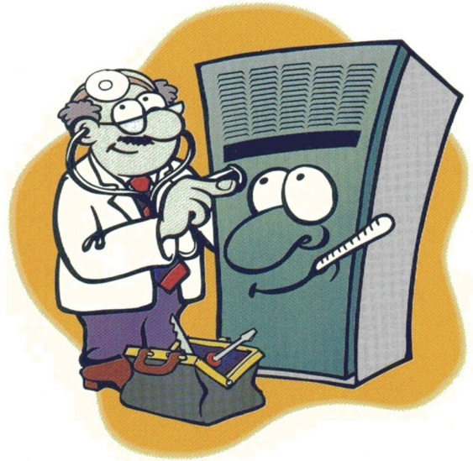
It’s spring and it’s time to get your A/C checkup just like us we have to get our yearly physical to make sure everything is working properly and to hopefully prevent if anything major from happening to our bodies. So in the same respect it is imperative for us to have (preventative maintenance) for our Refrigeration, A/C and Heating system to ensure longevity.
Call today and start the Spring & Summer season cooling and saving!
Ph.(404)819-2007 Fax. (770)728-9600
Email: pyron_hvac@yahoo.com
Web: www.pyronsmechanicalservices.com
Affordable Rates!!!
Lic. & Ins.
We are a full service company!
$500 off a new complete system installation
Must present coupon at time of service, some restrictions may apply.

Exp. 9/1/2019

$70 Tune-up Heating or A/C system
Must present coupon at time of service, some restrictions may apply.
Exp. 9/1/2019

$25 off service calls Heating or A/C.
Must present coupon at time of service, some restrictions may apply.
Exp. 9/1/2019

